Questionnaire Design Cheat Sheet

**Remember a good survey is like a good conversation. So, important features are:**

* Your questionnaire should have a brief, interesting title.
* Start with warm-up questions that are related the current behaviors
* Have transitions & use of sections approaches to keep related topics together. **See page 2**.
* Use rating scales wherever possible, while avoiding dichotomies or yes/no answers whenever possible. **See page 3**.
* Add demographic variables (such as class level, gender, residence location) at the end of the questionnaire. **See page 12**.
* Bottom line: Make sure that your Questionnaire questions can adequately answer your Research questions. What can the manager do about the information? **See page 13**.

**How to critique questionnaire**:

* Is it a good conversation? the instruction, layout, and flow of the questionnaire.
* Are the questions confusing? Can you answer the questions?
* Are there too many yes and no response options? Can the answers provide enough information for the manager to decision?

**Common mistakes:**

1. Format and Layout of the questionnaire: It should not just be a list of questions.
2. Introduction/instruction. See page 1, for example.
   1. Purpose of the research?
   2. Any incentive? How long will it take to finish the survey?
3. Logical flow:
   1. Qualifying question is not placed at the beginning.
   2. General to more specific questions (easier to harder questions)
   3. No separation of questions into different sections and description of them.
   4. Not placing demographic questions at the end:
      1. Not enough demographic questions to segment customers.
      2. The response options should be listed, not open-ended.
      3. You might want to convert the ratio scale into ordinal or interval.
4. Be specific:
   1. Yes-and-no questions: Use them mainly for screening and warm up questions.
   2. Try to use interval scales wherever possible and appropriate. Use 5 – 7 points of scale in most situations for interval questions instead of 3 points.
   3. For non-interval questions: ranking? Multiple or single choices? Be clear
   4. Listing the features (e.g., the satisfaction of service, taste, delivery etc.) See page 3.
   5. Describe the significant change (e.g., types of event, types of promotions) in detail
5. The wordings are not suitable for the intended respondents (existing vs. new customers). See page 8.
   1. Make sure the intended respondents can answer your questions.
   2. Pre-test your survey is the best way to identify these issues.

**Appendix with Examples:**

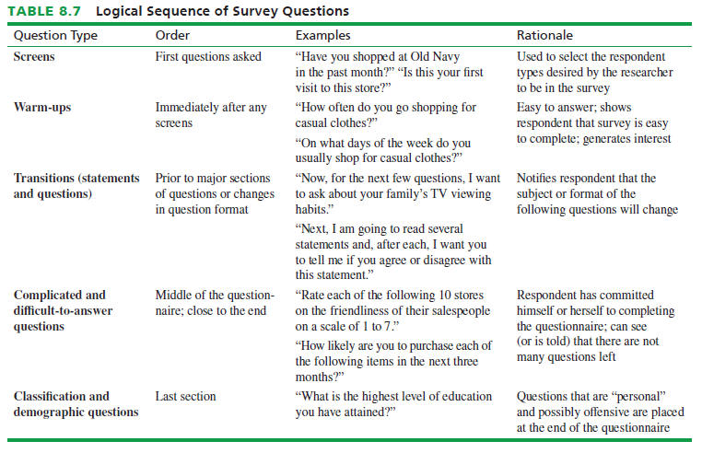

1. **Introduction:** makes sure you describe the business (e.g., uniqueness of the focal restaurant) concept well.

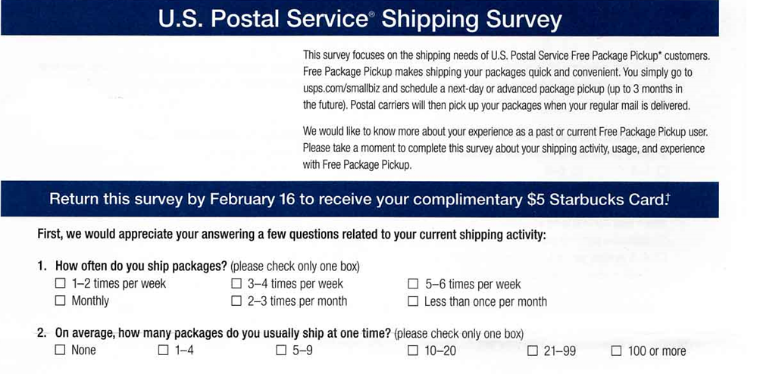

1. **Transitions and Sections example:**

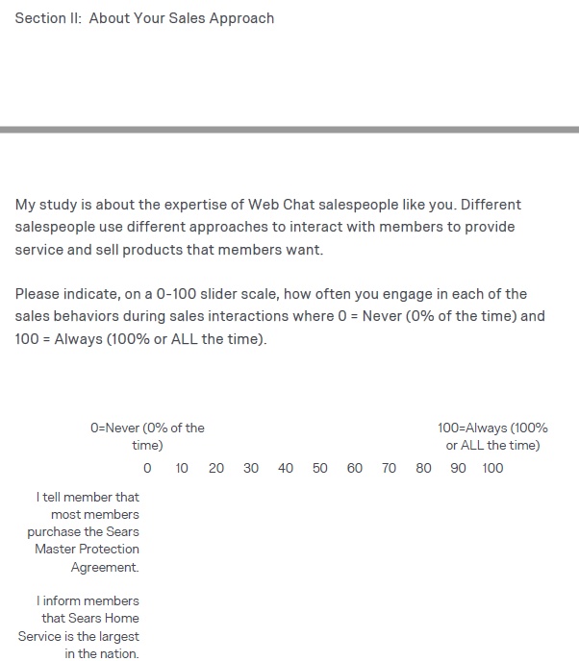

1. **Interval scales examples:**

----Features of satisfaction

1 
좋目우츠 
1 결ⅲ뎜 
4흫111ii 

----Features of the value

3. For each of the following, please rate the overall value 
given the fees you pay. 
Your trust r_elauonship with Wachovia 
The offered regarding your trust relationship with Wachovia O 
The provided regarding your trust relationship with Wachovia Trust...„ O 
O 
The Of your trust relationship with Wachovia Trust 
o 
o 
o 
o 
o 
o 
o 

*How satisfied are the members with Extreme Exposure's climbing facilities?*

Construct: Satisfaction. Satisfaction is one of the constructs described in Table 8.2.

Although Extreme Exposure has several aspects, satisfaction must be measured for each aspect. Here is an example scale based on the recommendation in Table 8.2.

Indicate for each feature of Extreme Exposure, how satisfied you are with its performance by circling the appropriate number.

|  |  |  |  |  |  |
| --- | --- | --- | --- | --- | --- |
| **Feature** | **Not at all Satisfied** | **Slightly Satisfied** | **Somewhat Satisfied** | **Very Satisfied** | **Completely Satisfied** |
| Location | 1 | 2 | 3 | 4 | 5 |
| Hours of operation | 1 | 2 | 3 | 4 | 5 |
| Prices | 1 | 2 | 3 | 4 | 5 |
| Vertical climbs | 1 | 2 | 3 | 4 | 5 |
| Number of climbing routes | 1 | 2 | 3 | 4 | 5 |
| Difficulty of climbing routes | 1 | 2 | 3 | 4 | 5 |

**Interval scale example on properties to be measured by for a grocery story**. Note the **various format** to organize them

1. *aspects of the image of Mike’s Market. In your work on this scale, you must do the following:*
2. *brainstorm the properties to be measured*
3. *determine the appropriate bipolar adjectives*
4. *decide on the number of scale points*
5. *indicate how the scale controls for the halo effect.*

Properties to be measured. A sample list is:

(1) prices,

(2) location,

(3) variety of merchandise,

(4) friendliness, and

(5) value.

Students may come up with others properties.

The semantic differential scale is provided below. A 5-point scale is used, but students may use 7 points. The midpoint stands for neutral or no opinion. Note that “merchandise variety” is flipped to obviate the halo effect.

Rate Mike’s Market…

High prices \_\_\_\_ \_\_\_\_ \_\_\_\_ \_\_\_\_ \_\_\_\_ Low Prices

Inconvenient location \_\_\_\_ \_\_\_\_ \_\_\_\_ \_\_\_\_ \_\_\_\_ Convenient location

Much merchandise variety \_\_\_\_ \_\_\_\_ \_\_\_\_ \_\_\_\_ \_\_\_\_ Little merchandise variety

Unfriendly salespeople \_\_\_\_ \_\_\_\_ \_\_\_\_ \_\_\_\_ \_\_\_\_ Friendly salespeople

Poor value for the price \_\_\_\_ \_\_\_\_ \_\_\_\_ \_\_\_\_ \_\_\_\_ Good value for the price

1. **Create a grid if you use the same response scales.**

Describe & options of promotions for different level of interest.

*How interested are its members in*

*(a) day trips to outdoor rock-climbing areas,*

*(b) group overnight and/or extended-stay rock climbing trips to the Canadian Rockies,*

*(c) single (one person), couple, and/or family rock-climbing adventures with a personal rock-climbing guide, and*

*(d) a rock climber certification program that would require at least five outside climbing sessions?*

Construct: Interest level

Interest can be measured on an interest continuum. The following example is a labeled scale, but students can use a synthetic number scale such as 1=Uninterested, 5=Very interested.

How interested are you in each of the following rock-climbing activities? Circle the number corresponding to your interest level for each one.

|  |  |  |  |  |  |
| --- | --- | --- | --- | --- | --- |
| **Feature** | **No interest** | **Little interest** | **Some interest** | **Moderate interest** | **Much interest** |
| Day trips to outdoor rock-climbing areas | 1 | 2 | 3 | 4 | 5 |
| Group overnight and/or extended-stay rock climbing trips to the Canadian Rockies | 1 | 2 | 3 | 4 | 5 |
| A rock climber certification program | 1 | 2 | 3 | 4 | 5 |

1. **Add condition of Competition & intention to buy with detail description of the item**

*Will members consider leaving Extreme Exposure to join a new rock-climbing center with climbs that are 10 feet higher than the maximum climb at Extreme Exposure?*

Construct: intentions to purchase

If another rock-climbing center opens in Sacramento with climbs that are 10 feet higher than the highest one at Extreme Exposure, how likely are you to consider joining the new center?

\_\_\_ Very Unlikely

\_\_\_ Somewhat Unlikely

\_\_\_ Neither Unlikely nor Likely

\_\_\_ Somewhat Likely

\_\_\_ Very Likely

*6. Will members consider leaving Extreme Exposure to join a new rock-climbing center with higher climbs and a lower annual membership fee?*

Construct: Intentions to purchase

The question could immediately follow the one about 10 feet higher walls.

If you found that this new center with climbs 10 feet higher than the highest one at Extreme Exposure charged an annual fee 20% lower than Extreme Exposure’s annual fee, how likely are you to consider joining the new center?

\_\_ Very Unlikely

\_\_\_ Somewhat Unlikely

\_\_\_ Neither Unlikely nor Likely

\_\_\_ Somewhat Likely

\_\_\_ Very Likely

1. **Warm up questions examples**

To begin, tell us a little about yourself.

1. What is your favorite television show type? (Select only one.)

Comedy Drama Movies/Mini-Series

News/Documentary Reality Science-Fiction Sports

1. What is your favorite radio genre? (Select only one.)

Classic Pop & Rock Country Easy listening

Jazz & Blues Pop & Chart Talk

1. What is your favorite magazine type? (Select only one.)

Business & Money Music & Entertainment Family & Parenting

Sports & Outdoors Home & Garden Cooking-Food & Wine

Trucks-Cars & Motorcycles News-Politics & Current Events

1. What is your favorite local newspaper section? (Select only one.)

Editorial Business Local news National news

Sports Entertainment

1. **Demographic questions should be put at the end of survey.**

Finally, the following questions will be used for classification purposes.

1. What is the size of your home town or city?

1 million and more 500,000 to 1 million 100,000 to 500,000

10,000 to 100,000 Under 10,000

1. What is your gender?

Male Female

1. What is your marital status?

Unmarried Married

1. What is the number of people in household? \_\_\_

1. What is your age category?

Less than 18 18 to 24 25 to 34 35 to 49

50 to 64 65 and older No response

1. What is your highest level of education?

Less than High School High School Diploma Some college

College Degree Post graduate degree

1. Which of the follow job category best describes you?

Management Sales Service Agriculture Craft General Labor Retired

1. What is your household income level?

Under $25,000 $25,000 to 49,000 $50,000 to 74,000

75,000 to 125,000 $125,000 and more

1. What is your primary dwelling type?

Single family Multiple family Condominium/Townhouse Mobile home

1. What is your primary vehicle price type?

No vehicle Economy Standard Luxury

1. What is your primary vehicle type?

No vehicle Car Pick-up truck SUV or van

1. Which of the following best your typical type of commuting to work?

Single occupancy Multiple occupancy Public transportation

Non-motorized Telecommute

1. **Note the differences in wordings on research objectives between different audiences (existing customers vs. new customers).**

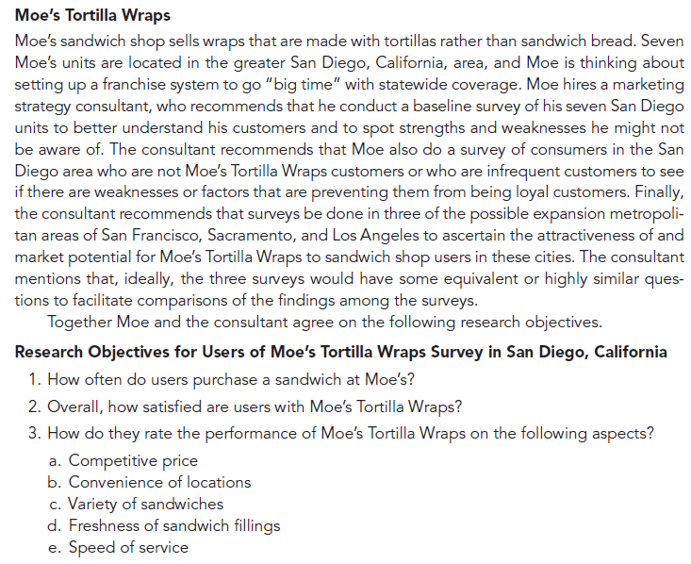

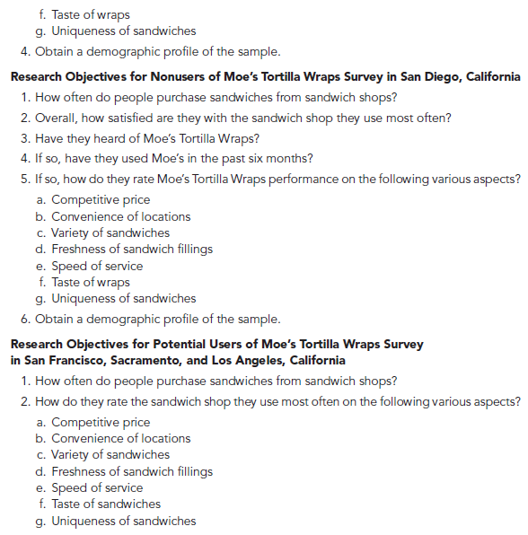

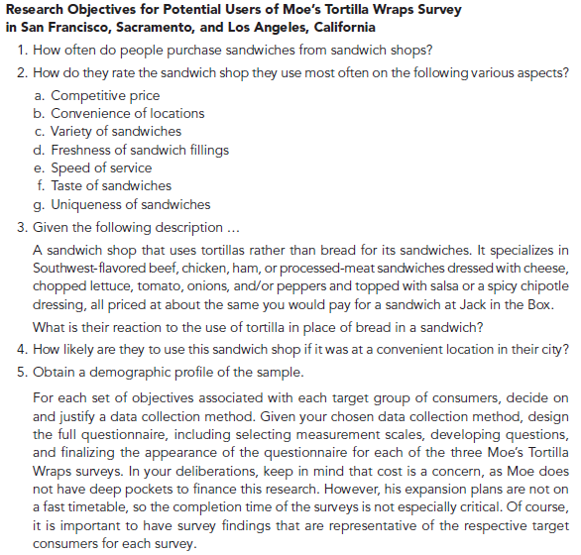

**Survey with a good description in the example of the question:**

This survey is being conducted for an automobile manufacturer seeking to develop new models of automobiles using synthetic or alternative fuel sources. It studies your opinions about global warming and gasoline usage as well as your reactions to some possible new automobile models.

To begin, tell us a little about yourself.

1. What is your favorite television show type? (Select only one.)

Comedy Drama Movies/Mini-Series

News/Documentary Reality Science-Fiction Sports

1. What is your favorite radio genre? (Select only one.)

Classic Pop & Rock Country Easy listening

Jazz & Blues Pop & Chart Talk

1. What is your favorite magazine type? (Select only one.)

Business & Money Music & Entertainment Family & Parenting

Sports & Outdoors Home & Garden Cooking-Food & Wine

Trucks-Cars & Motorcycles News-Politics & Current Events

1. What is your favorite local newspaper section? (Select only one.)

Editorial Business Local news National news

Sports Entertainment

Next, how do you feel about global warming, gasoline usage, and gasoline prices?

Indicate your degree of agreement or disagreement to each of the following statements. (Note: the scale for each question is Very strongly disagree, Strongly disagree, Disagree, Neither disagree nor agree, Agree, Strongly Agree, Very strongly agree.)

1. I am worried about global warming.
2. Global warming is a real threat.
3. We need to do something to slow global warming.
4. Gasoline emissions contribute to global warming.
5. Americans use too much gasoline.
6. We should be looking for gasoline substitutes.
7. Gasoline prices will remain high in the future.
8. Gasoline prices are too high now.
9. High gasoline prices will impact what type of autos are purchased.
10. Very small autos with very high mpg's will reduce fuel emissions.
11. Very small autos with very high mpg's will keep gas prices stable.
12. Very small autos with very high mpg's will slow down global warming.
13. Small autos with high mpg's will reduce fuel emissions.
14. Small autos with high mpg's will keep gas prices stable.
15. Small autos with high mpg's will slow down global warming.
16. Hybrid autos that use alternative fuels will reduce fuel emissions.
17. Hybrid autos that use alternative fuels will keep gas prices down.
18. Hybrid autos that use alternative fuels will slow down global warming.

Now, indicate on a scale of 0% to 100%, the probability of you making each of the following automobile purchases in the next three years.

1. Probability of buying a very small (1 seat) hybrid auto
2. Probability of buying a small (2 seat) hybrid auto
3. Probability of buying a standard size hybrid auto
4. Probability of buying a standard size synthetic fuel auto
5. Probability of buying a standard size electric auto

How do you feel about some possible new types of hybrid automobiles?

Indicate the how desirable each of the following hybrid automobile models is to you, personally. Use this scale: Very undesirable, Undesirable, Somewhat desirable, Neutral, Somewhat desirable, Desirable, Very desirable

1. Super cycle 1 seater; 120+ mpg city
2. Runabout Sport 2 seater; 90 mpg city, 80 mpg highway
3. Runabout with Luggage 2 seater; 80 mpg city, 70 mpg highway
4. Economy 4 seater; 70 mpg city; 60 mpg highway
5. Standard 4 seater; 60 mpg city; 50 mpg highway

Below are descriptions of various types of people. For each description, indicate on a scale where 1 = does not describe me at all and 7= describes me perfectly how well it describes you.

1. Novelist – very early adopter, risk taker, “way out,” “show off,” want to be unique and extraordinary
2. Innovator – early adopter, less risk taker than novelist, but into new technology; likes new products, but not “show offs”
3. Trendsetter – opinion leaders, well off financially and educationally, often the first adopters of new trends that are adopted by most of society.
4. Forerunner – early majority of population, respected and fairly well off; not opinion leaders, but adopt new products before the “average” person
5. Mainstreamer – late majority of population, “average people,” who are reserved and deliberate
6. Classic – laggards who cling to “old” ways

Finally, the following questions will be used for classification purposes.

1. What is the size of your home town or city?

1 million and more 500,000 to 1 million 100,000 to 500,000

10,000 to 100,000 Under 10,000

1. What is your gender?

Male Female

1. What is your marital status?

Unmarried Married

1. What is the number of people in household? \_\_\_
2. What is your age category?

Less than 18 18 to 24 25 to 34 35 to 49

50 to 64 65 and older No response

1. What is your highest level of education?

Less than High School High School diploma Some college

College Degree Post graduate degree

1. Which of the follow job category best describes you?

Management Sales Service Agriculture Craft General labor Retired

1. What is your household income level?

Under $25,000 $25,000 to 49,000 $50,000 to 74,000

75,000 to 125,000 $125,000 and more

1. What is your primary dwelling type?

Single family Multiple family Condominium/Townhouse Mobile home

1. What is your primary vehicle price type?

No vehicle Economy Standard Luxury

1. What is your primary vehicle type?

No vehicle Car Pick-up truck SUV or van

1. Which of the following best your typical type of commuting to work?

Single occupancy Multiple occupancy Public transportation

Non-motorized Telecommute

Thank you for participating in this survey.

**Bottom Line:**

**The examples to illustrate the difference between research questions (RQ) and questionnaire questions (QQ) for the CE1**.

* The research question is what the information manager would need.
* The corresponding questionnaire question is about how the research question can be asked to the consumer.

1. RQ: What percent of current customers would like a larger selection at the bookstore?

QQ: The selection of books at this store is....

\_\_ too small \_\_about right \_\_larger than I need

1. RQ: How likely are customers to use a coffee bar if it was added to the bookstore?

QQ: If an upstairs coffee bar was added to the bookstore, how often would you use it?

\_\_most times I visit the store

\_\_sometimes when I visit the store

\_\_rarely

\_\_never

1. RQ: What improvements would customers like to see at the bookstore?

QQ: Are there any changes you would like to see made to the bookstore?

If so, please describe